Architectural Design Document

**Introduction**

Risk game implemented is a modified version of the Risk board game.This document is used to represent the architecture pattern used in the game.Risk game is a board game.We have used MVC as our design pattern.It was an effort to use extreme programming effort with iterative software development approach to make a modular design and deliver several working coherent modules in small increments or builds.

**Model View Controller**

Model View Controller design aims at decomposing an interactive system into three components, namely: Model, View and Controller.

**Model** - The model represents data and the rules that govern access to and updates of this data. In enterprise software, a model often serves as a software approximation of a real-world process.

**View** - The view renders the contents of a model. It specifies exactly how the model data should be presented. If the model data changes, the view must update its presentation as needed. This can be achieved by using a push model, in which the view registers itself with the model for change notifications, or a pull model, in which the view is responsible for calling the model when it needs to retrieve the most current data.

**Controller** - The controller translates the user's interactions with the view into actions that the model will perform. In a stand-alone GUI client, user interactions could be button clicks or menu selections. Depending on the context, a controller may also select a new view -- for example, an action on a particular click event may result in rendering a completely new view.

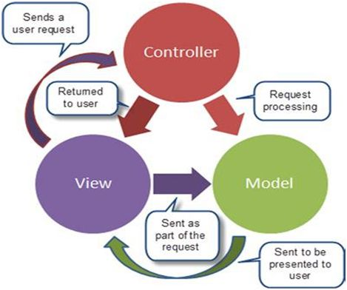

**Fig1. Basic MVC architecture**

The packages used in the game are shown in Fig.2. Figure 3 shows the architectural pattern followed in the game.

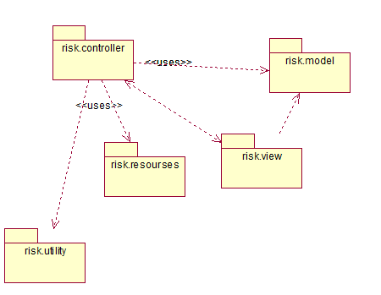

**Fig. 2 Package Diagram for overall MVC structure**

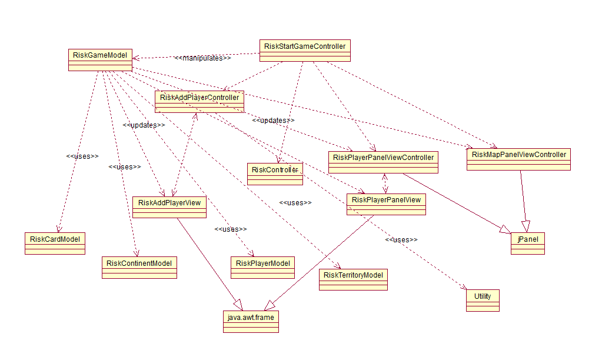

**Fig.3 Class Diagram**

**References**

* <http://www.oracle.com/technetwork/articles/javase/index-142890.html>
* <http://www.java-forums.org/attachments/ocmjea/3449d1333636384t-tutorial-review-web-tier-application-architecture-java-architect-exam-c5-conceptualmvc.jpg>